**DT211C-2 CA2 HCI**

Lingscar.com  
Topic Area: Business

REPORT AND EVALUATION

**Date:** 28th April, 2020

**Student Number: C18302166**

**Student Name: Michael Tennyson**

**Table of Contents**

Introduction 1

System Requirements 1

Design Methods 2

Life Cycle Model 2

Cognitive Frameworks 2

Interaction Styles 2

Input & Output devices 3

Evaluation methods 3

Prototypes 4

Low Fidelity Prototype 4

Enhanced Low Fidelity Prototype 4

Evaluation of Low Fidelity Prototype 6

Medium Fidelity Prototype 6

Evaluation of Medium Fidelity Prototype 8

Conclusion 9

References 10

INTRODUCTION

*The website that I identified needing a better interface is lingscars.com. the reason for this is because I saw that the webpage has a very poor interface that was difficult to navigate. This was the main reason as to why I chose this website.*

SYSTEM REQUIREMENTS

I saw that current interest lacked proper usability functions. The websites interface is very bad and I saw that it could use a massive improvement in usability requirements. The main users of the website would be adults looking to purchase a vehicle. I made sure to note the main role of my new model was to make a model that’s layout would be easier to use based on recognition of icons and symbols.

DESIGN METHODS

LIFE CYCLE MODEL

*Describe the process or life-cycle model you have chosen to support the re-design. Indicate how it facilitates user-centered re-design and development.*

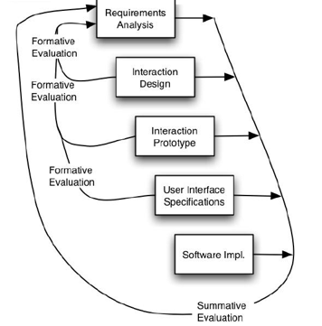

The Usability engineering life cycle helped me re develop lingscars.com. This development model I used also me to re-iterate sections of the cycle very easily and made development more smooth.

COGNITIVE FRAMEWORKS

*I made sure, when designing the model, to use Icons that’s are easily recognizable. So the user can see the purpose of a certain tab and have an easy time navigating the website. I made sure to sketch text in different fonts defined and separating text. I laid out the page in a way so it can be easily learned.*

INTERACTION STYLES

*The main interaction style that I decided to follow when designing my low fidelity prototype was metaphors. I made sure to look at ways that I could make design my interface making sure it has high usability value.*

INPUT AND OUTPUT DEVICES

*Describe the I/O devices (interaction devices) you have used to support the interaction styles described above. Explain why you have chosen these devices.*

EVALUATION METHODS

The Nielsons heuristics models was used to evaluate my interface models, I helped me look at what needed to be improved on in the prototype. The severity of the errors that I made in my previous models were noted and removed.

PROTOTYPES

LOW FIDELITY PROTOTYPE

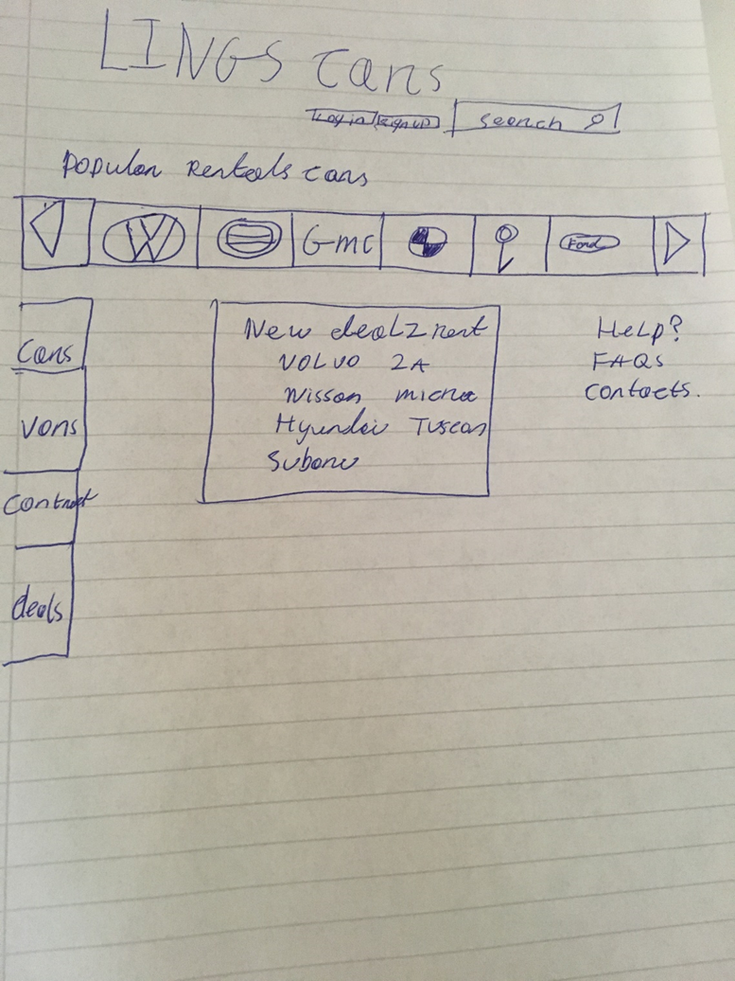

*Example low fidelity prototype*

ENHANCED LOW FIDELITY PROTOTYPE

*Example enhanced low fidelity prototype*

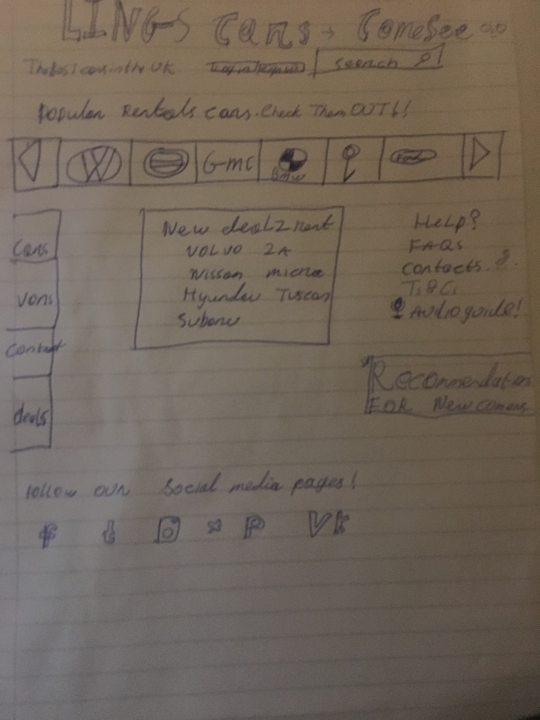

EVALUATION OF ENHANCED LOW FIDELITY PROTOTYPE

What I took from my low fidelity prototype when evaluating it using neilsons heuristics is that my model needed less text, Making it simple and usable for all users. I kept the use of icons to indicate the purpose of certain tabs.

MEDIUM FIDELITY PROTOTYPE

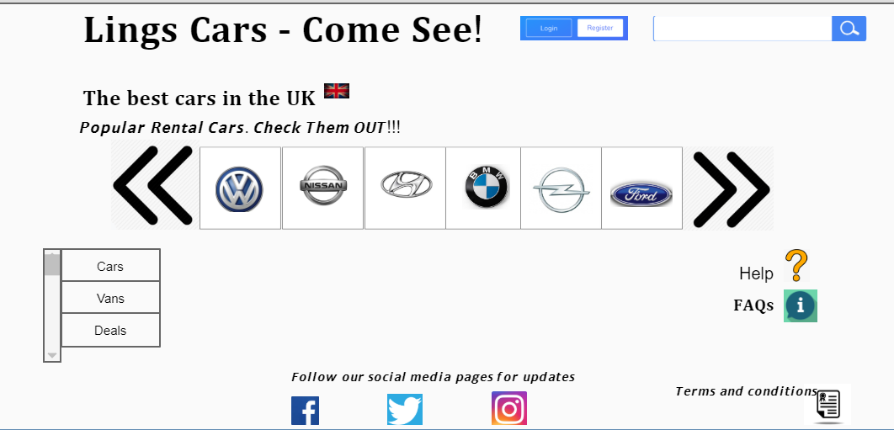

EVALUATION OF MEDIUM FIDELITY PROTOTYPE

I took from my evaluation of the medium fidelity prototype lacked any severe errors that needed to be removed. Was consistent in its design and fitted recognition patterns over memory.

CONCLUSION

*I have learned a lot from this assessment I have undertaken. I have gained more knowledge on the nielsons heuristics model in its use of evaluating prototypes. Following the Usability engineering model helped me lay out the process of designing my models. Overall, I have learned a lot from this Assignment*

REFERENCES

1. <https://www.nissan.ie/>
2. <https://www.volkswagen.ie/en/models/>
3. <https://www.hyundai.ie/new-cars>
4. <https://www.opel.ie/>
5. <https://www.ford.ie/cars>
6. <https://www.bmw.ie/en/all-models.html>